**GLOBAL GROUP OF INSTITUTES, AMRITSAR**

Six Months Training Project Report

On

**“FOOD BASKET”**

Submitted in the Partial fulfillment of the requirement for the Award of Degree of

**Bachelors of Technology**

**In**

**COMPUTER SCIENCE & ENGINEERING**



**SUBMITTED BY:**

Name: Tarunpreet Kaur

University Roll No: 1705852

**SUBMITTED TO:**

Department of CSE

**ACKNOWLEDGEMENT**

In the accomplishment of this project successfully, many people have bestowed upon me their blessings and the heart pledged support, this time I am utilizing to thank all the people who have been concerned with this project.

Primarily, I would like to thank God for being able to complete this project with success. Then, I would like to thank “**Global Group of Institutes**” for providing with an opportunity to pursue our minor project as it is important part of B. Tech and it is the one that expose us to the industry standards and make us adapt our self to the latest technologies. I am also very grateful to faculty members of **Department of Computer Science** and Technology for their intellectual support throughout the training Course.

**Tarunpreet Kaur**

**B.Tech (CSE)**

**1705852**

**TABLE OF CONTENT**

**CHAPTER-1**

**Introduction to Project**

1.1) About Food Basket -----------------------------------------------------------------1

1.2) Objective of Food Basket ----------------------------------------------------------2

1.3) Features of Food Basket -----------------------------------------------------------3-4

**CHAPTER-2**

**Technologies Used**

2.1) Java ----------------------------------------------------------------------------------5-10

2.2) Java Server Pages (JSP) ----------------------------------------------------------10-12

2.3) SQL ------------------------------------------------------------------------------------12

2.4) HTML ---------------------------------------------------------------------------------13

2.5) CSS -------------------------------------------------------------------------------------14

2.6) BOOTSTRAP ------------------------------------------------------------------------15

2.7) JAVASCRIPT ---------------------------------------------------------------------16-17

**CHAPTER-3**

**Hardware and Software Requirements --------------------------------------------**18

**CHAPTER-4**

**Design** -----------------------------------------------------------------------------------19-22

**CHAPTER-5**

**Snapshots ---------------------------------------------------------------------------**23-34

**CHAPTER-6**

**Future Implementation --------------------------------------------------------------**36

**CHAPTER-7**

**Conclusion ------------------------------------------------------------------------------**37

**BIBLIOGRAPHY ---------------------------------------------------------------------**37

**LIST OF FIGURES**

Fig-1) Sign In ---------------------------------------------------------------------------------------- 23

Fig-2) Sign Up --------------------------------------------------------------------------------------- 23

Fig-3) View Categories----------------------------------------------------------------------------- 24

Fig-4) Special Offers-------------------------------------------------------------------------------- 24

Fig-5) View Products ---------------------------------------------------------------------------------25

Fig-6) View Cart ------------------------------------------------------------------------------------ 25

Fig-7) My Orders ------------------------------------------------------------------------------------- 26

Fig-8) Admin Login ---------------------------------------------------------------------------------- 26

Fig-9) Admin Home ---------------------------------------------------------------------------------- 27

Fig-10) Add Category -------------------------------------------------------------------------------- 27

Fig-11) Manage Merchants -------------------------------------------------------------------------- 28

Fig-12) Merchant Login------------------------------------------------------------------------------ 28

Fig-13) Add Product----------------------------------------------------------------------------------- 29

Fig-14) Product Detail-------------------------------------------------------------------------------- 29

Fig-15) Add Review----------------------------------------------------------------------------------- 30

Fig-16) Footer ----------------------------------------------------------------------------------------- 30

Fig-17) Change Password ---------------------------------------------------------------------------- 31

Fig-18) Ratings ---------------------------------------------------------------------------------------- 31

Fig-19) Orders ---------------------------------------------------------------------------------------- 32

Fig-20) Order Details -------------------------------------------------------------------------------- 32

Fig-21) Merchants ------------------------------------------------------------------------------------ 33

Fig-22) Categories ------------------------------------------------------------------------------------ 33

Fig-23) Users ------------------------------------------------------------------------------------------ 34

**CHAPTER-1**

**1.1) INTRODUCTION TO PROJECT**

Food Basket is an **online grocery channel store which is web based project that is made for remote shopping through Internet**. As the technology being advanced the way of life is changing accordance.Now a day’s we can place order from our home. There is no need to go to store of the things we want. The order can be placed online through Internet. The Payment, confirmation of purchasing, we can do everything. People have to suffer to rush of the market when they went for shopping. They has to think about to buy anything having sufficient amount of money. The problem was rush, the quarrel at the time for buying. But advancement of Technology brought new way of shopping. Some of the key features of Food Basket are free home delivery, no minimum order value, express delivery, no questions asked return policy and more. Itfollows**an on-demand model**.The result of online ordering will give easy to make ordering and hopefully smoothen up the job. This will give the computerized system in defining the best solution in each ordering. It helps in changing the system from manual to computerized system.

**CHAPTER - 1**

**1.2) OBJECTIVES OF PROJECT**

The objective of this project is to learn about java language with better understanding to imply the learning and knowledge on practical basis. This project has three modules that are Admin Module, User Module and Merchant Module. Admin module has right to access the merchant and user side. In user module user can create an account and login into His/Her account. In merchant module, merchant has its own merchant ID, which is assigned by admin as it accepts the approval to that particular merchant. Merchant can manage the products where as user can buy that particular product and admin can delete or remove that product. User, merchant and admin can change their password.There are several objectives of “Food Basket” are as follows:

* It gives all information about e-shopping to provide better services for the customers.
* It provides the facility to customers who want to shop online due to lock time.
* It provides facility to customer to payment by cash, cheque, DD or by any mode of payment.
* It provides full details about the product and related information about the product like cost, quantity etc.
* With help of this, we can save time.

**CHAPTER – 1**

**1.3) FEATURES OF PROJECT**

**ADMIN:-**

1. **Login Module**: Admin can enter Username and password to login using this module.

2. **Change / Recover Password Module**: This module allows admin to change or recover password.

3. **Add Category**: Add category like fruits vegetable grosery or daily home products

4. **Add Item**: Add items under category.

5. **Accept or Reject Order**: To accept or reject the order request.

6. **View Order History**: Admin can view history of Orders (Accepted, Delivered, Rejected, Canceled)

7. **Feedback**: Details of reviews and ratings posted by users.

8. **Daily Sale**: View daily sale.

9. **Logout**: Redirect to Login page.

**USER:-**

1. **Signup**: User signup with details.

2. **Login**: User login using credentials.

3. **Change Password**: Change Password.

4. **Recover Password**: Recover password using email or mobile number.

5. **Search Product**: User can search a Product using category or product name.

6. **Cart:** Add Items to Cart.

7. **Booking**: Select date and time and make payment to order product.

8. **Order History**: View order history

9. **Rate/Review**: Rate and review.

**MERCHANTS:-**

1. **Signup**: Merchant signup with details.

2. **Login**: Merchant login using credentials.

3. **Change Password**: Change Password.

4. **Recover Password**: Recover password using email or mobile number.

5. **Manage Products:** Add product by choosing category name.

6. **View Gallery:** Can add two or more images of product.

7. **Logout:** Logout by vanishing details.

**CHAPTER 2**

**TECHNOLOGIES USED**

**2.1 JAVA**

Java is a general purpose and the most popular object-oriented programming language. Java was developed by James Gosling and his colleagues at Sun Microsystems in the early 1990’s.

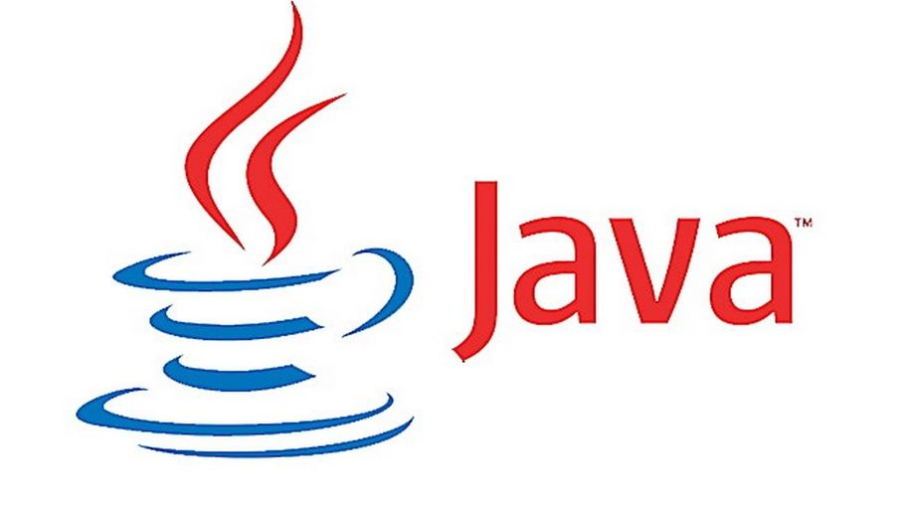

Due to its simplicity and easy to learn and advanced features, we opted this language for our six months industrial training. This language supports many interesting features that make it an ideal language for software development. In addition to the object oriented features, it also provides features such as platform independence, security, multithreading, portability; etc which makes it well suited for the web and networked services, applications, platform-independent desktops, robotics and any other embedded devices*.*

**Features of Java**

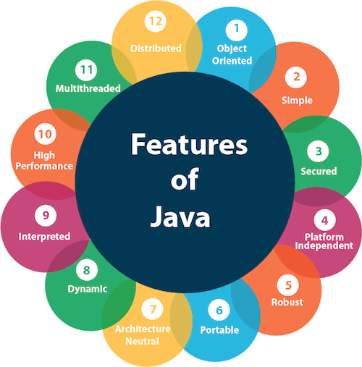

* **Simple**: Java is a compact and simple language. Programs are easy to write and debug as it omits many clumsy, poorly understood and confusing features of other programming languages such as C++.
* **Object-oriented:** Java is purely object-oriented language because programming in java is centered on creating objects; manipulating objects and making objects work together.
* **Distributed:** Java is a distributed language which means that the programs can be designed to run on computer networks. Java provides an extensive library of classes for communicating using TCP/IP protocols such as HTTP and FTP. This makes creating network connections much easier.
* **Robust:** Java is designed for writing programs that are highly robust. By robust, we mean reliable.
* **Secure:** As java is intended to be used in networked/distributed environments so it implements several security mechanisms to protect you against malicious code that might try to invade your file system.
* **Architectural Neutral:** This means that the programs written on one platform can run on any other platform without having to rewrite or recompile them. It follows ‘Write-once-run-anywhere’ approach.
* **Portable:** In Java, the size of the primitive data types is machine independent. These consistencies make java program portable among different platforms such as Windows, UNIX and Mac.
* **Interpreted:** Java is such a language that is both compiled and interpreted. The two steps of compilation and interpretation allow extensive code checking and improved security.
* **High performance:** Java programs are complied with portable intermediate form known as byte codes, rather than to native machine level instructions and JVM executes java byte codes on any machine on which it is installed. This architecture means that java programs are faster.
* **Multithreaded:** Java is also a multithreaded programming language. It allows you to write a program that can do many tasks simultaneously.
* **Dynamic:** Java is designed to be dynamic. Classes are stored in separate files and are loaded into the Java Interpreter only when they are needed.
* **Platform Independent:** Java is platform independent. Because the Java compiler converts the source code to bytecode, which is Intermidiate Language. Bytecode can be executed on any platform (OS) using JVM( Java Virtual Machine).

**JAVA DEVELOPMENT KIT (JDK)**

The Java Development Kit (JDK) is a software package that sun has made available to public. It includes all the basic components that makeup the java environment. These include the Java compiler, Java Interpreter, an applet viewer that lets you see applets without opening a Java-compatible web browser.

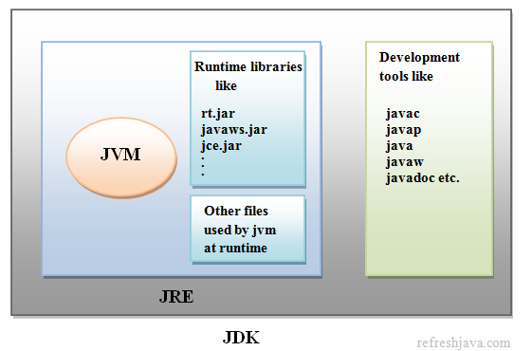

**APPLICATIONS OF JAVA**

Java has evolved from a simple language providing interactive dynamic content for webpage’s to a predominant enterprise-enables programming language suitable for developing significant and critical applications.

Today, Java is used for many applications like:

* Web based applications
* Financial applications
* Gaming applications
* Embedded applications
* Distributed enterprise applications
* Mobile applications
* Image applications
* E-business applications
* Desktop applications and many more.

**SOCKET PROGRAMMING IN JAVA**

Clients and Servers establish connections and communicate via sockets. Connections are the communication links that are created over the Internet using TCP. Some client/server applications are also building around the connectionless UDP. These applications also use sockets to communicate.

**A Socket is an abstraction through which an application, may send and receive data.**

There are two types of sockets used in socket programming in java:

* **Stream Socket:** A Stream Socket is a connection oriented socket. Thus a connection has to be established before it can send or receive data. Data that one end of the connection writes to the socket is available for reading at the other end of the socket connection. The Stream Sockets use TCP protocol for data transmission.
* **Datagram Socket:** Datagram Socket is a connectionless socket, thus no actual connection is established between two communicating hosts. The datagram socket use UDP protocol for data transmission. Since UDP does not guarantee that all packets are received in the correct order or not. Also with UDP the packets can even be lost or dispatched.
* **Raw Sockets:** Some protocols such as ICMP or OSPF that directly us the services of IP, use neither stream nor datagram sockets. Raw Sockets are designed for these types of applications.

**The java.net package contains fundamental classes for communication and working with network resources.**

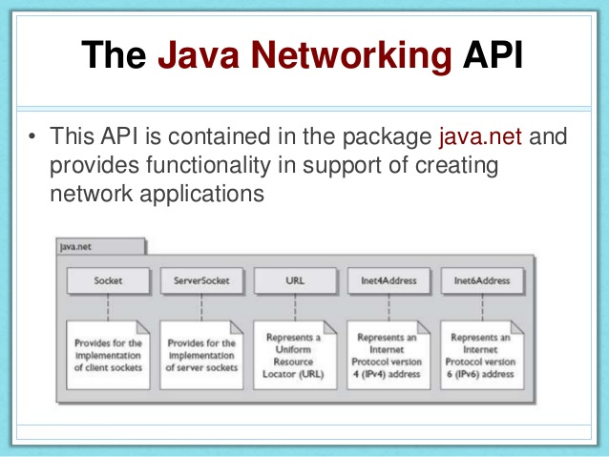

**2.2 JSP**

**Java Server Pages (JSP)**

Java Server Pages (JSP) is a server-side programming technology that enables the creation of dynamic, platform-independent method for building Web-based applications. JSP have access to the entire family of Java APIs, including the JDBC API to access enterprise databases. This tutorial will teach you how to use Java Server Pages to develop your web applications in simple and easy steps.

Basically, any html file can be converted to JSP file by just changing the file extension from “.html” to “.jsp”, it would run just fine. What differentiates JSP from HTML is the ability to use java code inside HTML. In JSP, you can embed Java code in HTML using JSP tags. for e.g. run the code below, every time you run this, it would display the current time. That is what makes this code dynamic.

JSP technology is used to create dynamic web applications. JSP pages are easier to maintain then a Servlet. JSP pages are opposite of Servlets as a servlet adds HTML code inside Java code, while JSP adds Java code inside HTML using JSP tags. Everything a Servlet can do, a JSP page can also do it.

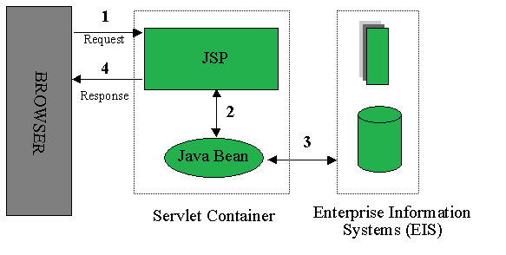

JSP enables us to write HTML pages containing tags, inside which we can include powerful Java programs. Using JSP, one can easily separate Presentation and Business logic as a web designer can design and update JSP pages creating the presentation layer and java developer can write server side complex computational code without concerning the web design. And both the layers can easily interact over HTTP requests.

**Advantages of JSP:**

* Easy to maintain and code.
* High Performance and Scalability.
* JSP is built on Java technology, so it is platform independent.

**2.3 SQL**

SQL stands for Structured Query Language. SQL is a standard language for accessing and manipulating databases. SQL can execute queries against a database. SQL can retrieve data from a database. It inserts records in a database.It update records in a database. It deletes records from a database. It can create new databases. It creates new tables in a database. Also create stored procedures in a database. It creates views in a database. It set permissions on tables, procedures, and views.

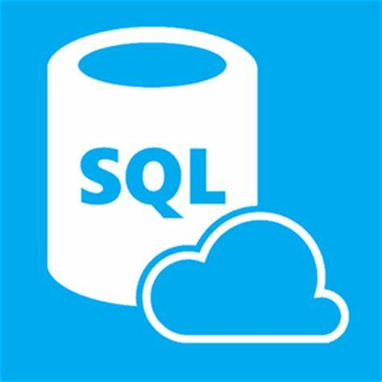

To build a web site that shows data from a database, you will need:

* An RDBMS database program (i.e. MS Access, SQL Server, MySQL)
* To use a server-side scripting language, like PHP or JSP
* To use SQL to get the data you want
* To use HTML / CSS to style the page.

**2.4 HTML**

HTML stands for Hyper Text Markup Language. HTML is the standard markup language for creating Web pages. It describes the structure of a Web page. It consists of a series of elements. HTML elements tell the browser how to display the content. HTML elements label pieces of content such as "this is a heading", "this is a paragraph", "this is a link", etc.It is used to design the front end portion of web pages using markup language. HTML is the combination of Hypertext and Markup language. The markup language is used to define the text documentation within tag which defines the structure of web pages.HTML-5 is the fifth and latest major version of HTML that is a World Wide Web Consortium (W3C) recommendation. The current specification is known as the HTML Living Standard and is maintained by a consortium of the major browser vendors (Apple, Google, Mozilla, and Microsoft), the Web Hypertext Application Technology Working Group (WHATWG).Its goals were to improve the language with support for the latest multimedia and other new features, to keep the language both easily readable by humans and consistently understood by computers and devices such as web browsers, parsers, etc., without XHTML's rigidity and to remain backward-compatible with older software. HTML5 is intended to subsume not only HTML 4 but also XHTML 1 and DOM Level 2 HTML. HTML code ensures the proper formatting of text and images for your [Internet browser](https://www.computerhope.com/jargon/b/browser.htm). Without HTML, a browser would not know how to display text as elements or load images or other elements. HTML also provides a basic structure of the page, upon which [Cascading Style Sheets](https://www.computerhope.com/jargon/c/css.htm) are overlaid to change its appearance. One could think of HTML as the bones (structure) of a web page, and CSS as its skin (appearance).



**Features of HTML**

* It is a very **easy and simple language**. It can be easily understood and modified.
* It is very easy to make an **effective presentation** with HTML because it has a lot of formatting tags.
* It is a **markup language**, so it provides a flexible way to design web pages along with the text.
* It facilitates programmers to add a **link** on the web pages (by html anchor tag), so it enhances the interest of browsing of the user.
* It is **platform-independent** because it can be displayed on any platform like Windows, Linux, and Macintosh, etc.
* It facilitates the programmer to add **Graphics, Videos, and Sound** to the web pages which makes it more attractive and interactive.
* HTML is a case-insensitive language, which means we can use tags either in lower-case or upper-case.

**2.5 CSS**

**C**ascading **S**tyle **S**heets, fondly referred to as **CSS**, is a simply designed language intended to simplify the process of making web pages presentable. It describes how HTML elements are to be displayed on screen, paper, or in other media. It saves a lot of work. It can control the layout of multiple web pages all at once. External stylesheets are stored in CSS files. CSS allows you to apply styles to web pages. More importantly, CSS enables you to do this independent of the HTML that makes up each web page. CSS is easy to learn and understood but it provides powerful control over the presentation of an HTML document. CSS is used to define styles for your web pages, including the design, layout and variations in display for different devices and screen sizes.

**CSS Versions:**

* 1. CSS1
  2. CSS2
  3. CSS3
  4. CSS4

Version 4 comes with:-

* + - CSS-Pro
    - CSS-Mobile



**Features of CSS**

* CSS saves time as you can write CSS once and then reuse same sheet in multiple HTML pages. You can define a style for each HTML element and apply it to as many Web pages as you want.
* It loads Pages faster that is if you are using CSS, you do not need to write HTML tag attributes every time. Just write one CSS rule of a tag and apply it to all the occurrences of that tag. So less code means faster download times.
* To make a global change, simply change the style, and all elements in all the web pages will be updated automatically.
* CSS has a much wider array of attributes than HTML, so you can give a far better look to your HTML page in comparison to HTML attributes.

**2.6 BOOTSTRAP**

Bootstrap is the most popular HTML, CSS, and JS framework for developing responsive, mobile first projects on the web. Bootstrap makes front-end web development faster and easier. It's made for folks of all skill levels, devices of all shapes, and projects of all sizes. Bootstrap is the most popular HTML, CSS and JavaScript framework for developing responsive, mobile-first websites.

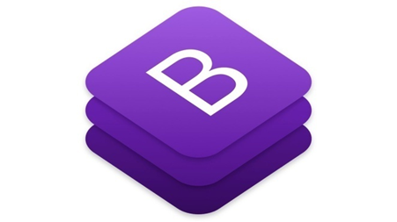

**Features of Bootstrap:**

The primary purpose of adding it to a web project is to apply Bootstrap's choices of color, size, font and layout to that project. As such, the primary factor is whether the developers in charge find those choices to their liking. Once added to a project, Bootstrap provides basic style definitions for all HTML elements. The result is a uniform appearance for prose, tables and form elements across web browsers. In addition, developers can take advantage of CSS classes defined in Bootstrap to further customize the appearance of their contents.

**2.7 JAVASCRIPT**

JavaScript is a lightweight, interpreted programming language. It is designed for creating network-centric applications. It is complimentary to and integrated with Java. JavaScript is very easy to implement because it is integrated with HTML. It is open and cross-platform. JavaScript usage has now extended to mobile app development, desktop app development, and game development. This opens many opportunities for you as Javascript Programmer.

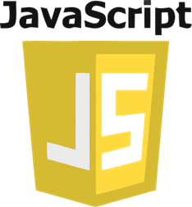

## Applications of Javascript Programming

Javascript is one of the most widely used programming languages (Front-end as well as Back-end). It has it's presence in almost every area of software development. I'm going to list few of them here:

* **Client side validation** - This is really important to verify any user input before submitting it to the server and Javascript plays an important role in validting those inputs at front-end itself.
* **Manipulating HTML Pages** - Javascript helps in manipulating HTML page on the fly. This helps in adding and deleting any HTML tag very easily using javascript and modify your HTML to change its look and feel based on different devices and requirements.
* **User Notifications** - You can use Javascript to raise dynamic pop-ups on the webpages to give different types of notifications to your website visitors.
* **Back-end Data Loading** - Javascript provides Ajax library which helps in loading back-end data while you are doing some other processing. This really gives an amazing experience to your website visitors.
* **Presentations** - JavaScript also provides the facility of creating presentations which gives website look and feel. JavaScript provides RevealJS and BespokeJS libraries to build a web-based slide presentations.
* **Server Applications** - Node JS is built on Chrome's Javascript runtime for building fast and scalable network applications. This is an event based library which helps in developing very sophisticated server applications including Web Servers.

**CHAPTER - 3**

**HARDWARE AND SOFTWARE REQUIREMENTS**

**HARDWARE REQUIREMENTS:**

Hardware requirements include that hardware which is required for its working. It includes:

* i3 or i5 Computer
* 4GB RAM
* 2 GB of available disk space minimum
* High Speed Internet Connection(DSL/Cable)

**SOFTWARE REQUIREMENTS:**

The software is developed using Netbeans. It can run and maintained with expertise on computers .Its user friendliness is not limited to the simplicity and ease of operation .The technical specifications of requirements for the software are as follows:

* Any Operating System (Windows, Linux, MAC)
* Java Development Kit(JDK).
* Netbeans IDE
* MySQL Server
* MySQL Workbench.
* Any web browser(Chrome, Firefox, etc)

**CHAPTER-4**

**DESIGN**

4.1) **DATA FLOW DIAGRAM (DFD)**

**Admin**

* Login
* Change password
* Manage Categories
* Manage Merchants
* View Products
* View Orders
* Logout
* Login
* Sign up
* Change Password
* View Categories
* Place order
* View Cart
* Logout

**Level 0 [DFD]**

**User**

* Login
* Sign up
* Change Password
* Manage Products
* View Orders
* Logout

**Merchant**

**Database**

**Food Basket Server**

**Level 1 (Add Product)**

**Admin**

Product added

**Database**

**User**

**Yes**

**No**

**Database**

**Level 1 (Search Product)**

Product not found

**Yes**

**User**

**No**

**Level 1 (Login)**

Login fail

**Database**

**Level 1 (Add Category)**

Category already exists

**Admin**

Category added

**Database**

**No**

**Yes**

4.2) **ER-DIAGRAM**

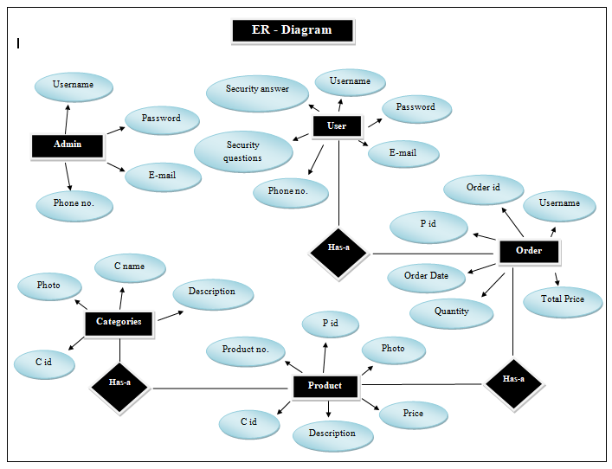

**CHAPTER-6**

**SNAPSHOTS**

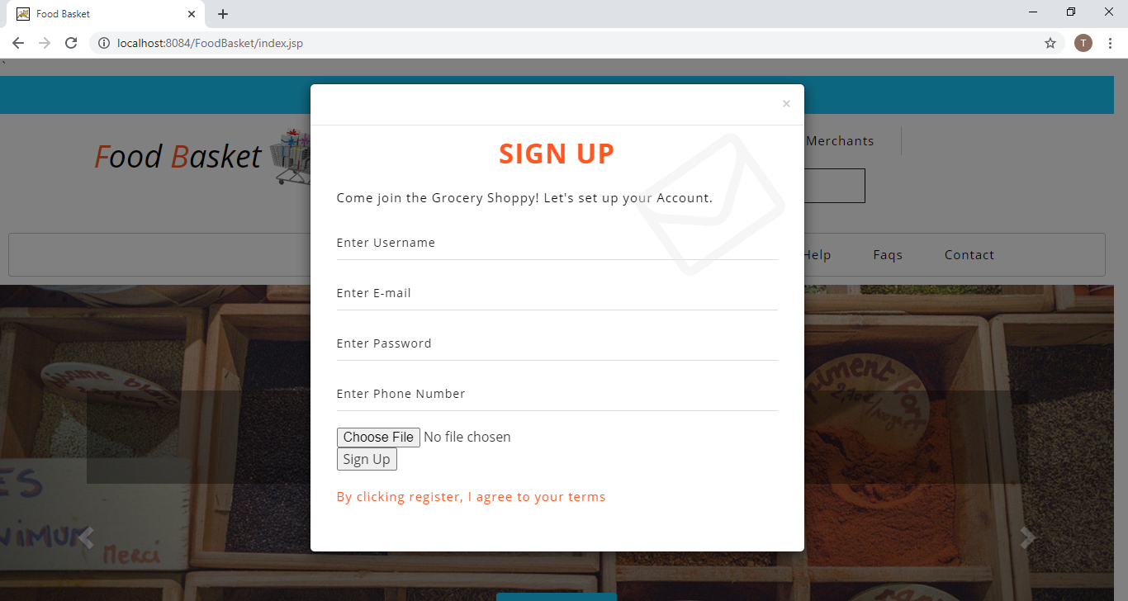

Fig 1- Sign Up

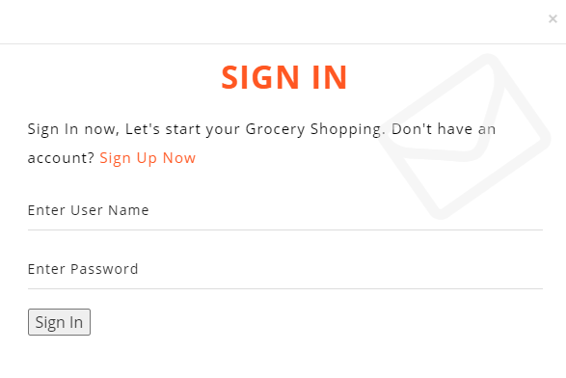

Fig 2- Sign In

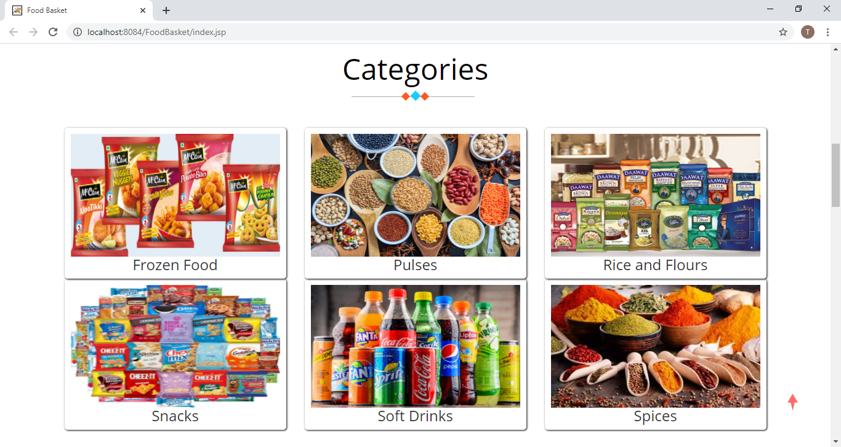

Fig 3- View Categories

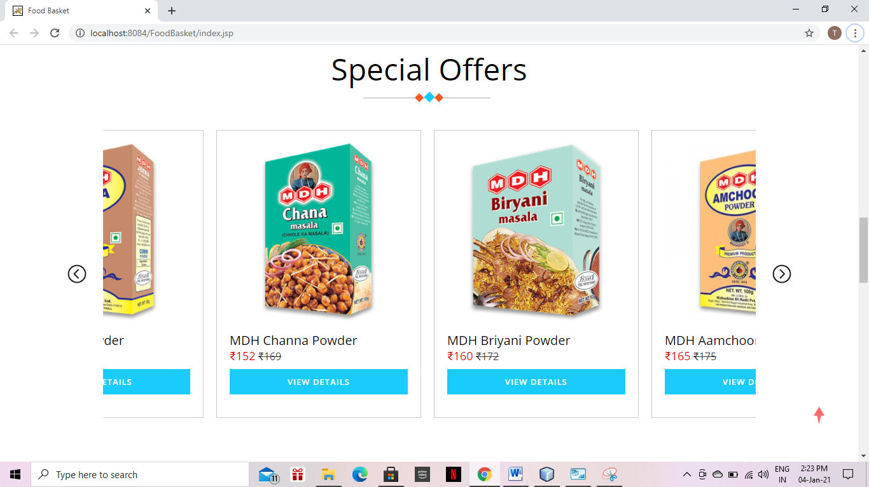

Fig 4 – Special Offers

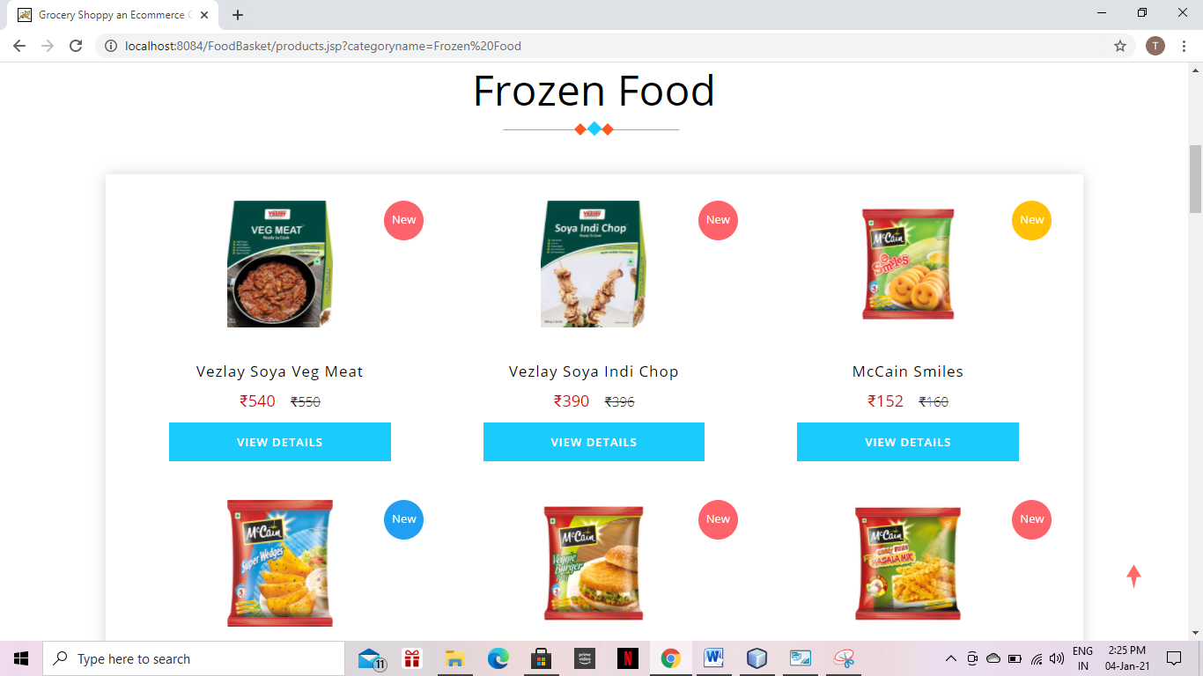

Fig 5 – View Products

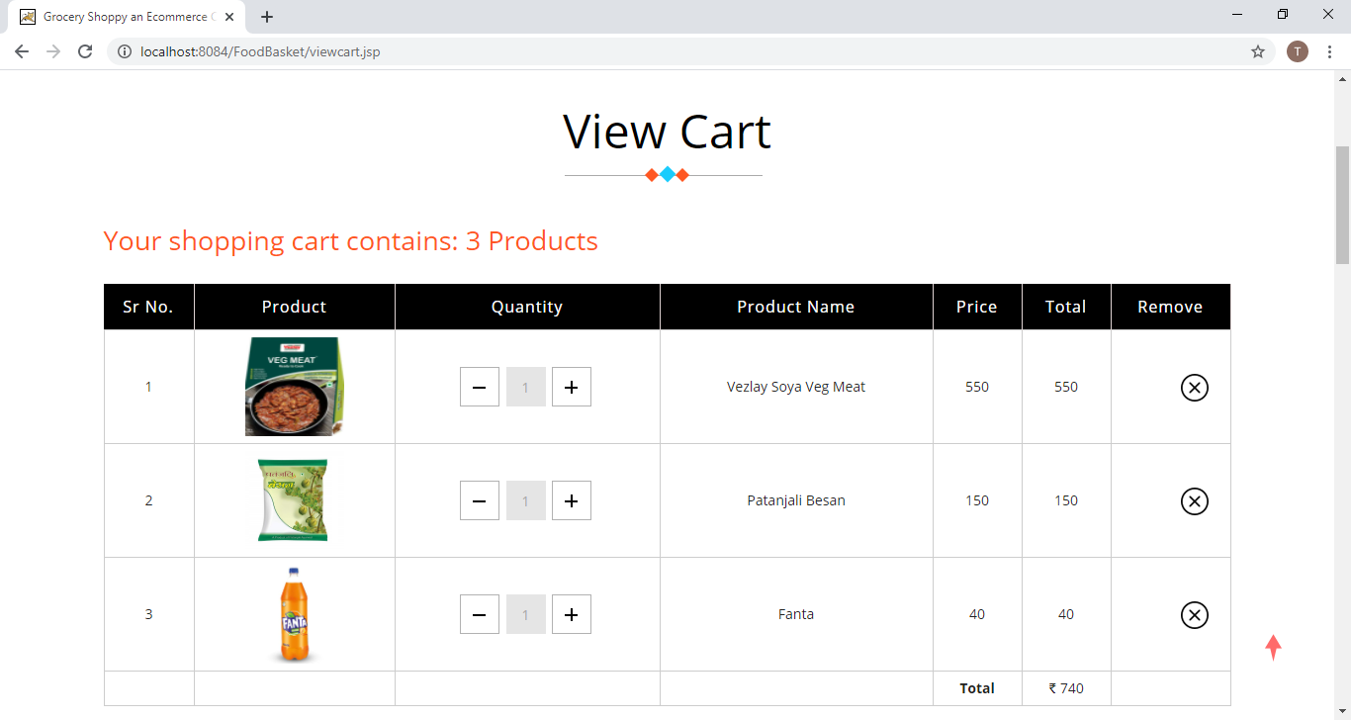

Fig 6 - View Cart

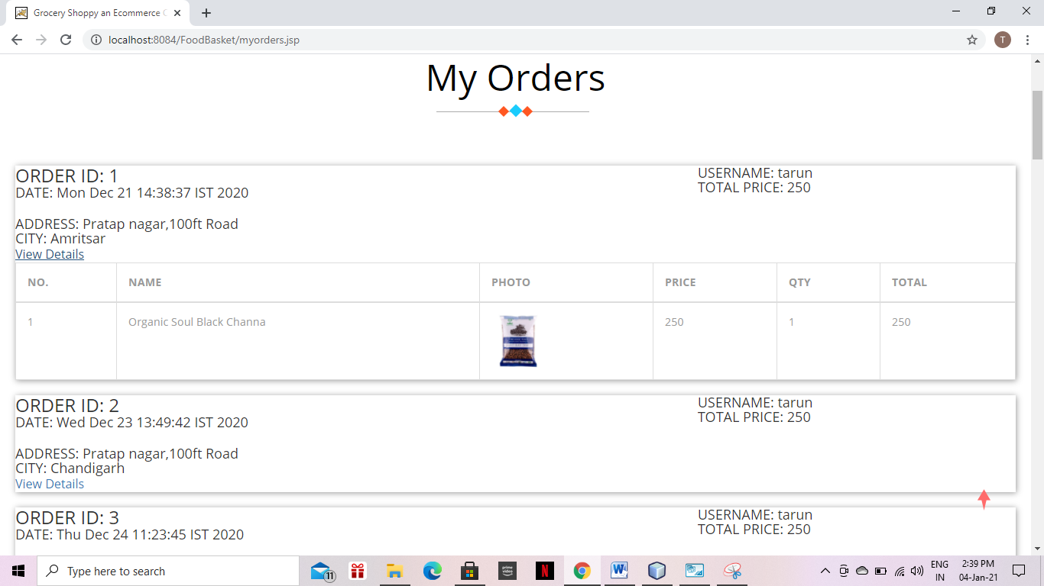

Fig 7 – My Orders

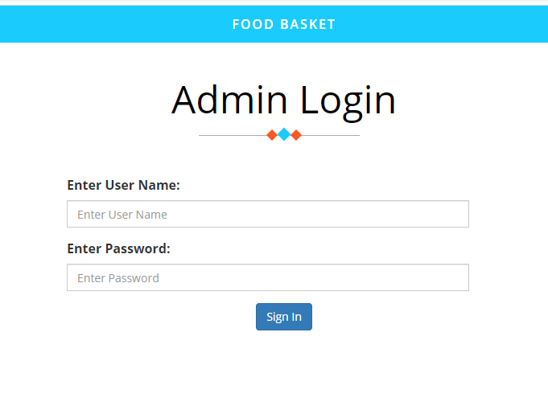

Fig 8 – Admin Login

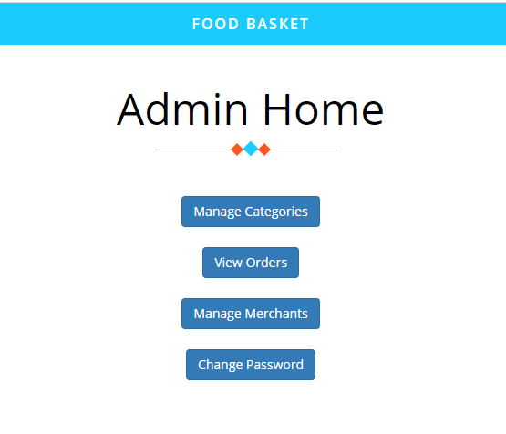

Fig 9 – Admin Home

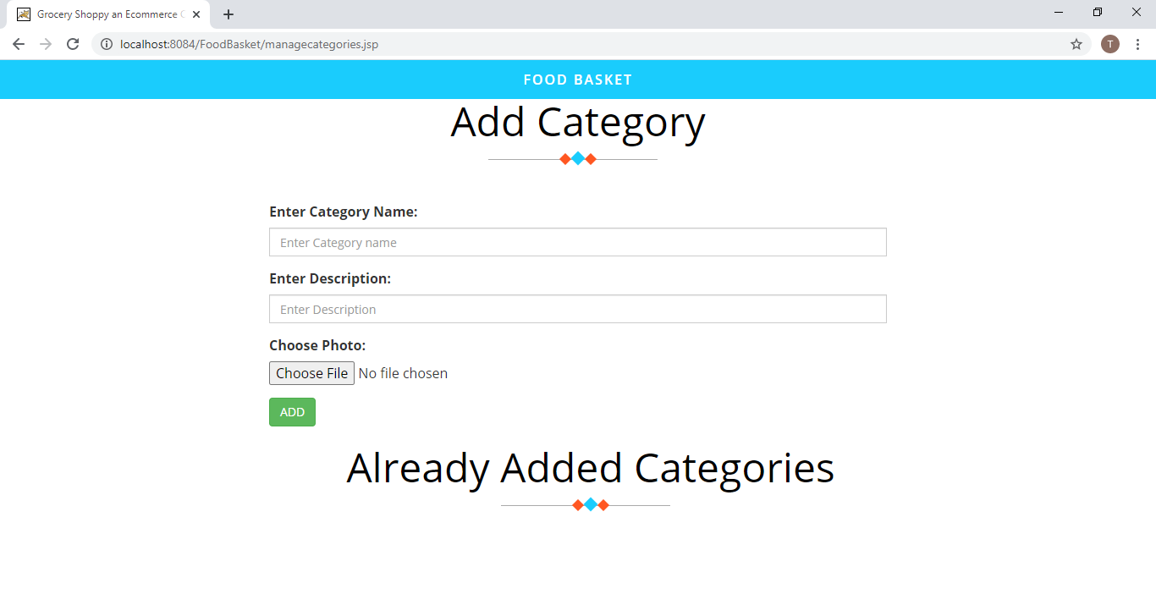

Fig 10 – Add Category

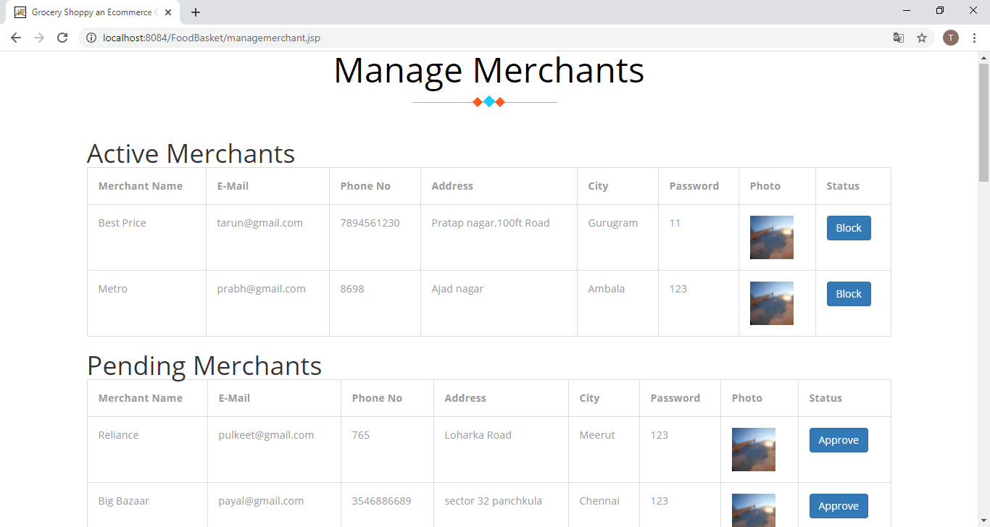

Fig 11 – Manage Merchants

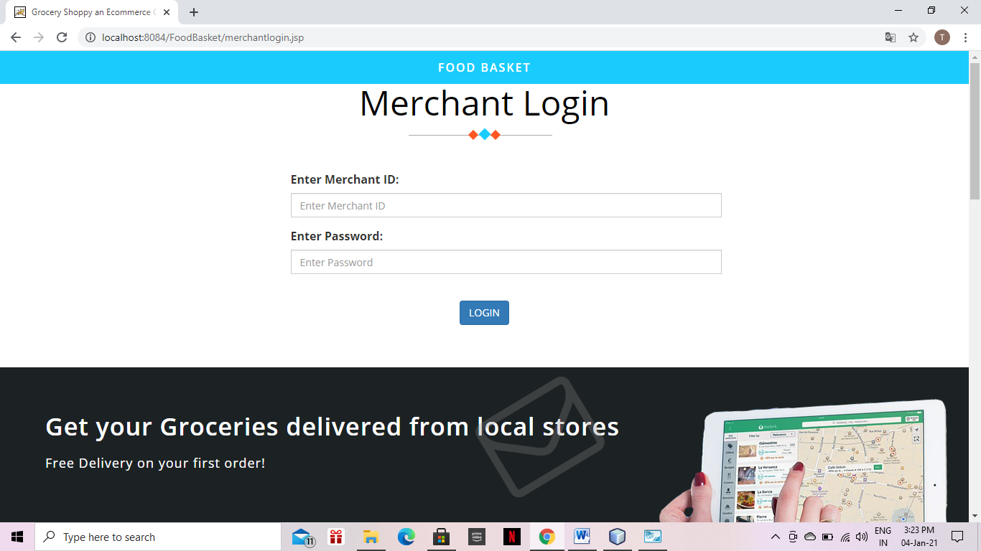

Fig 12 – Merchant Login

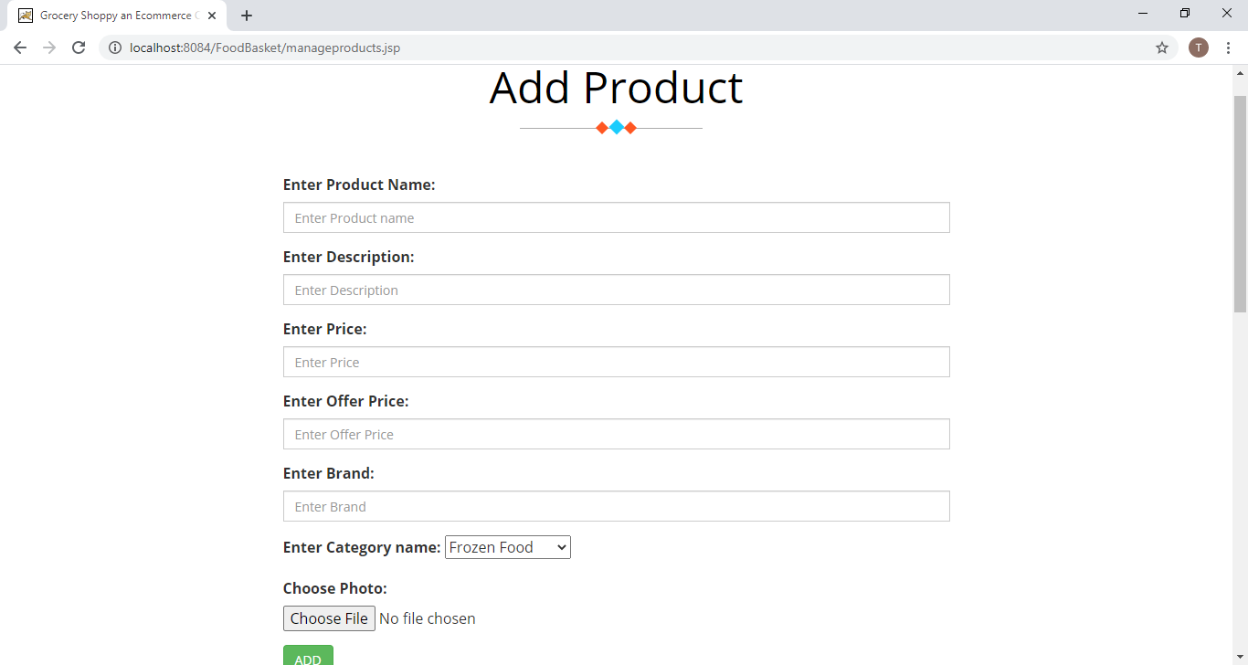

Fig 13 – Add Product

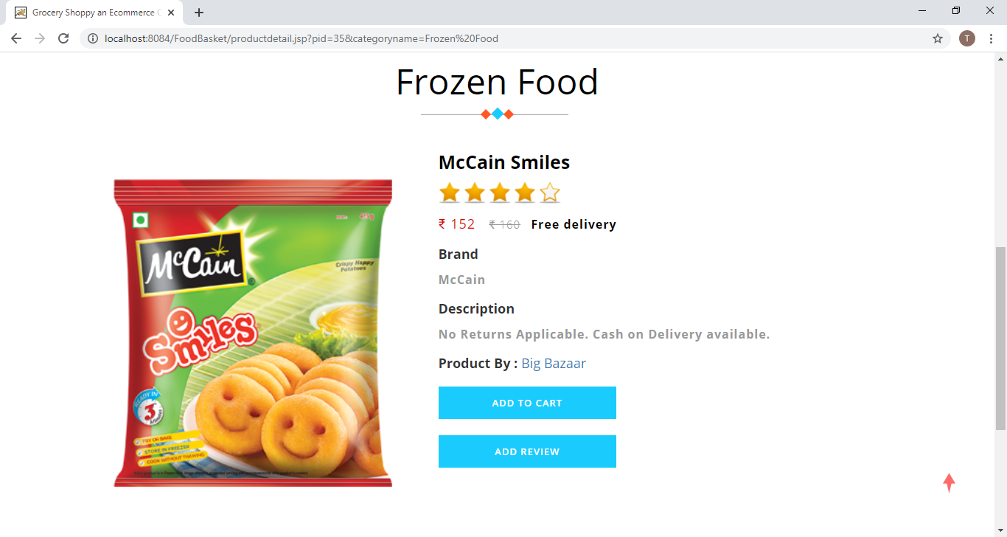

Fig 14 – Product Details

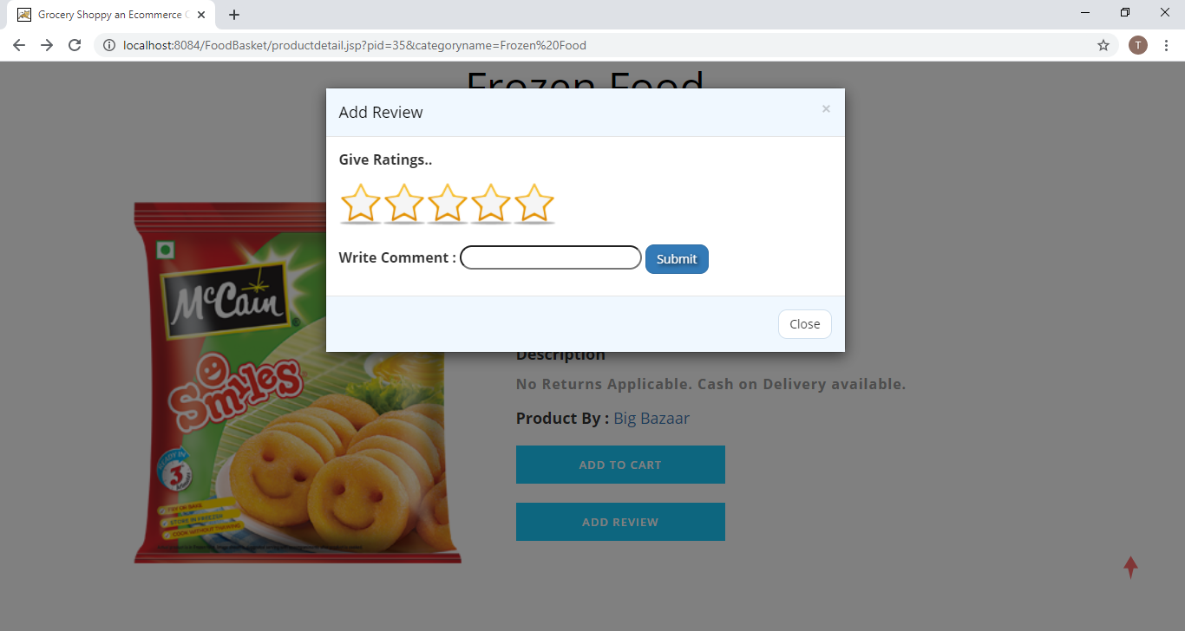

Fig 15 – Add Review

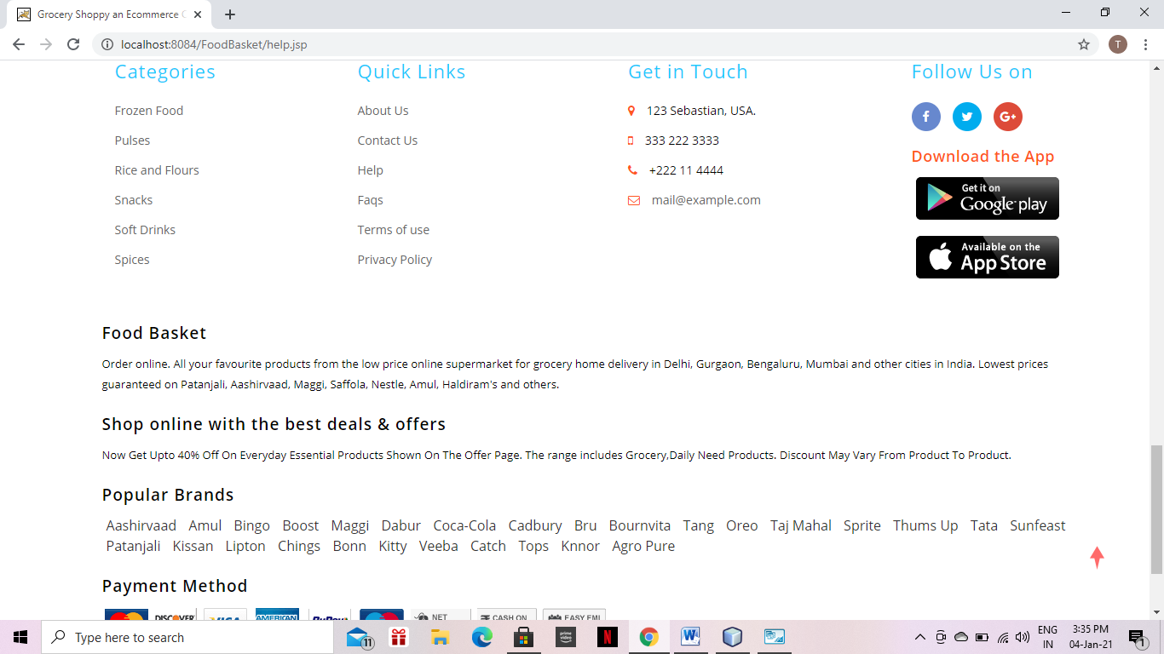

Fig 16 - Footer

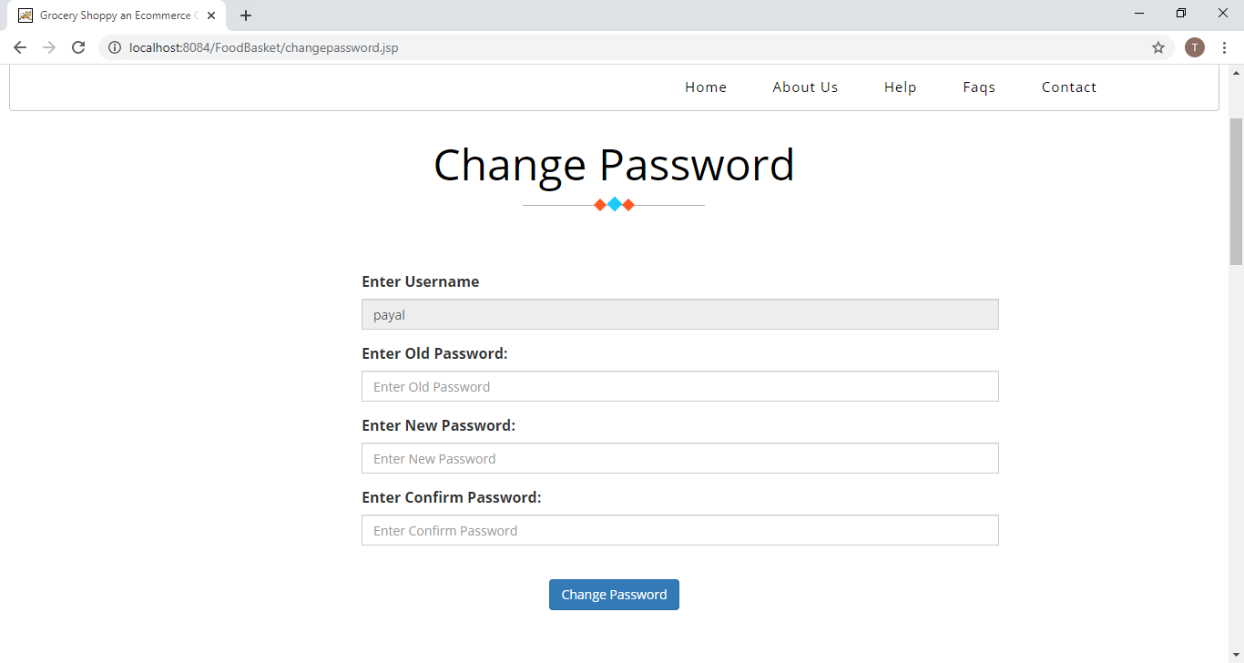

Fig 17 – Change Password

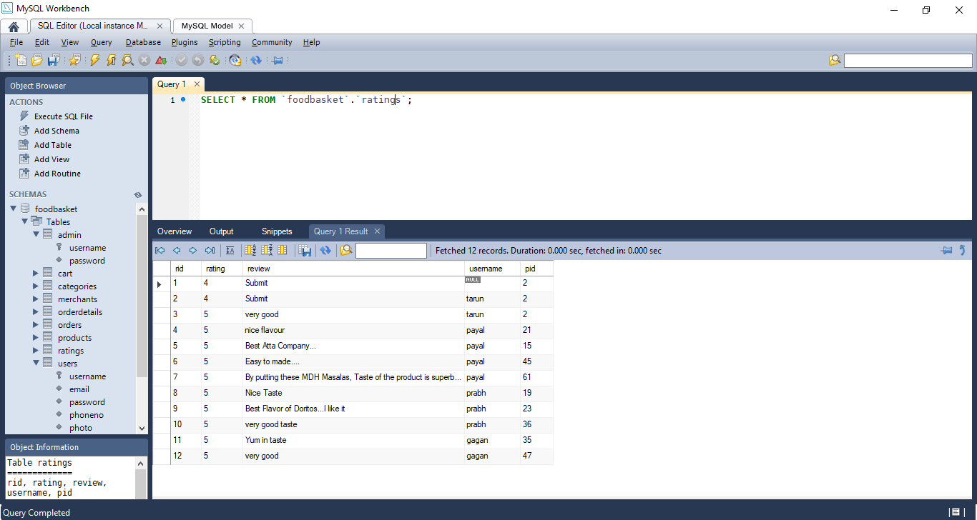

Fig 18 - Ratings

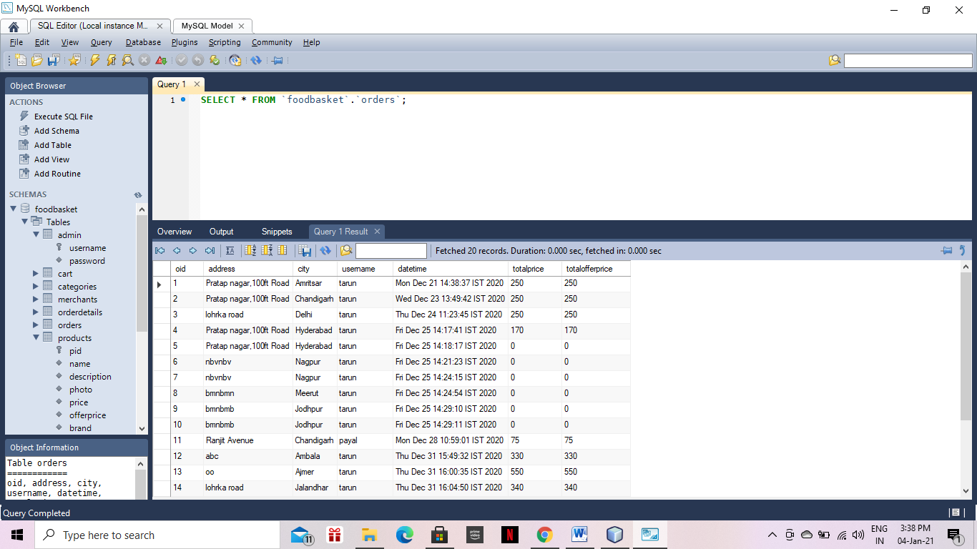

Fig 19 - Orders

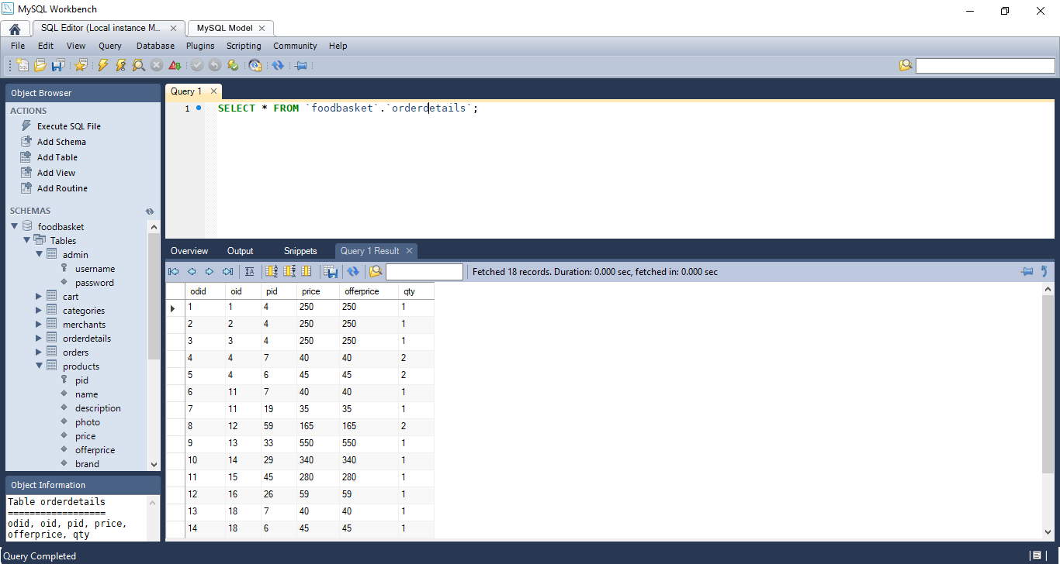

Fig 20 – Orderdetails

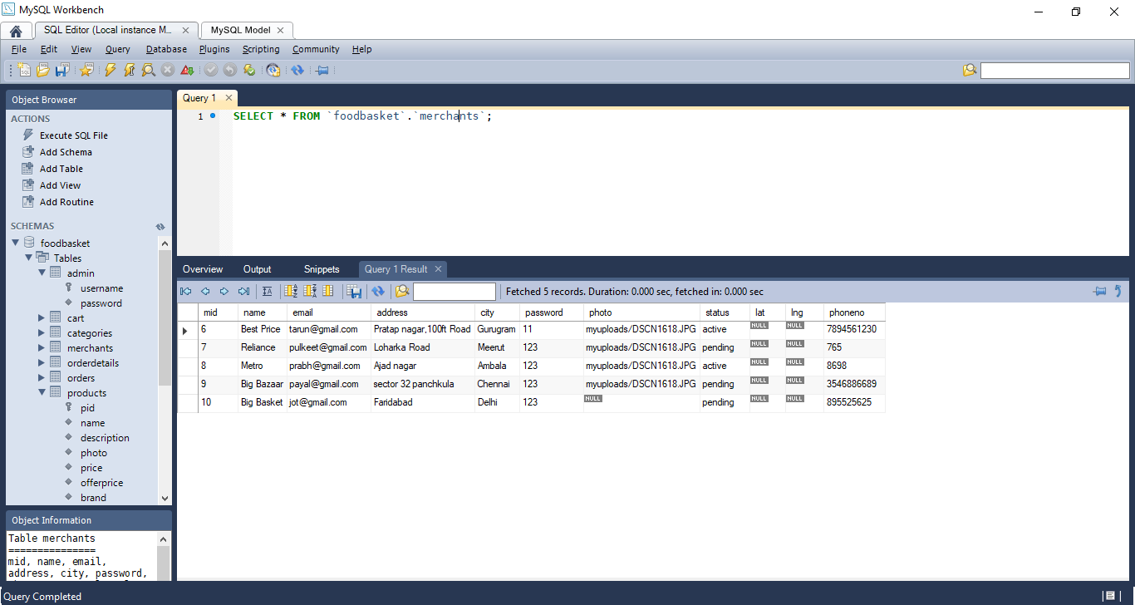

Fig 21 - Merchants

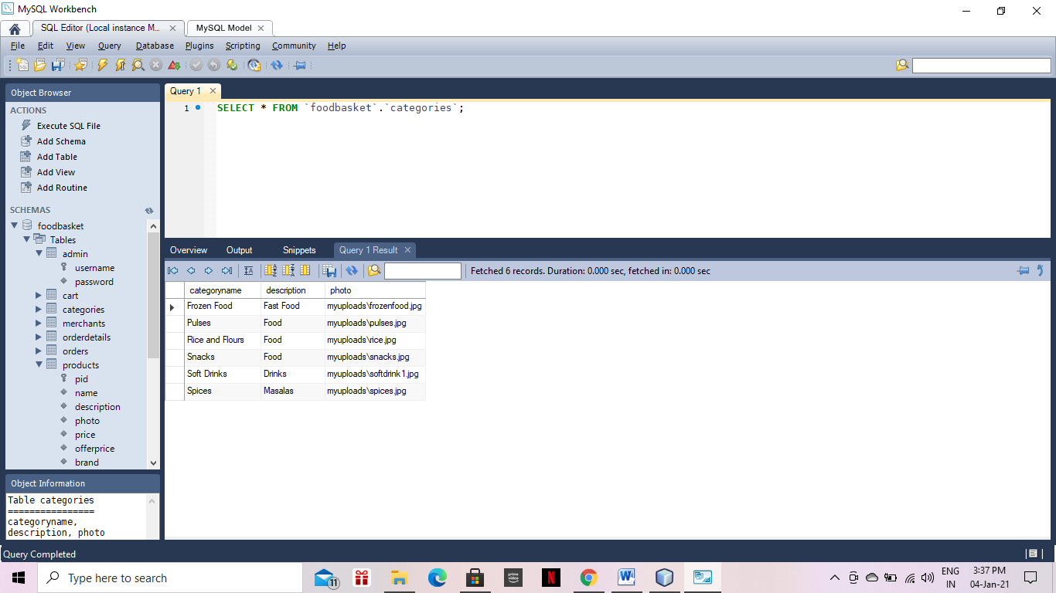

Fig 22 - Categories

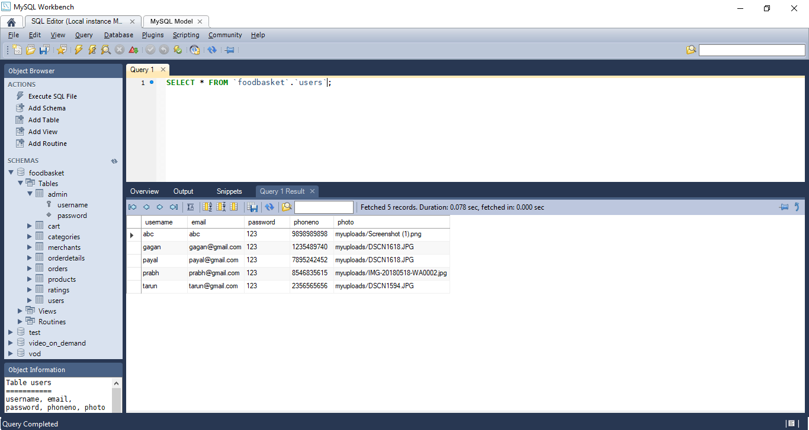

Fig 23 - Users

**CHAPTER - 6**

**FUTURE IMPLEMENTATION**

The project has a very vast scope in future. The project can be implemented on intranet in future. Project can be updated in near future as and when requirement for the same arises, as it is very flexible in terms of expansion. Further we can add agents. Those person will sell our products to customers and get comission on that basis. Then after we make android app and implement all features on app. Basically app and web will syc. This will give the computerized system in defining the best solution in each ordering.

In future, we will try to make this website which work so flexible and beneficial for customer and also try to make smooth service.

**CHAPTER - 7**

**CONCLUSION**

As no system design is ever perfect as communication problem, programmer’s lack of knowledge or time constraints creates error .The availibity of this project has produced a more educated comsumer that can shop around with relative ease without having to send large amount of time. In exchange, this project has opened up doors to many small retailers that would never be in business if they had to incure the high cost of owning a brick and remote store. At the end, it has been a win-win situation for both cosumer and sellers. A perfect project is that in which there is a minimum key punching .The number of errors in future in a new design depends upon several factors.

**Some of responsible factors are:**

* Communication between user and designer.
* The programmer’s ability to generate a code that reflects exactly the system specification.
* The timer frame for the design.

In my project, I have tried my best to cover each aspect carefully and accurately. On further analysis, the drawbacks of the system will show themselves which will further need modifications.

**BIBLIOGRAPHY**

To bring the system to verge of completion the following books have been referred:

|  |  |
| --- | --- |
| **NAME OF THE BOOK** | **AUTHOR’S NAME** |
| Java : The Complete Reference | Herbert Schildt |
| Sun Certified Java Programming | Kathy Sierra |

Some websites referred are: -

1. <https://www.javatpoint.com/>
2. <https://getbootstrap.com/docs/4.5/>
3. https://www.tutorialspoint.com/
4. <https://www.w3schools.com/>